**HR Scorecard Measuring Success in Talent Management**

**1. Introduction.**

***1.1 Overview***

The HR scorecard is a strategic HR measurement system that helps to measure, manage, and improve the strategic role of the HR department.

The Tableau HR Scorecard is a framework designed to measure and evaluate the success of talent management strategies within an organization. It provides a way for HR professionals and business leaders to track and analyse key performance indicators (KPIs) related to workforce planning, recruitment, retention, and development.

***1.2 Purpose***

An HR scorecard visually represents the critical measures of the HR department’s achievements productivity levels, and other parameters – such as hiring costs retention rate, time to fill, quality of hire, and so on- critical to the company’s growth .

Today, HR aids and enables other departments such as sales and marketing, finances, and operations to contribute meaningfully to organizational strategies.

**2. Problem Definitions and Design Thinking**

**a. Empathy Map**

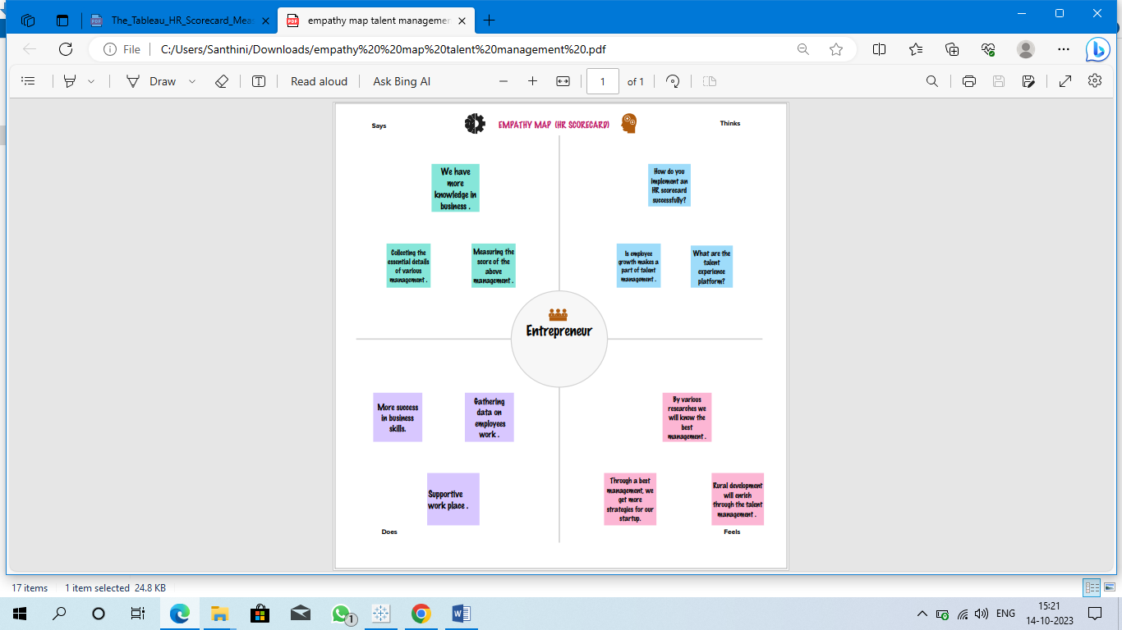

b. Ideation and Brainstroming Map

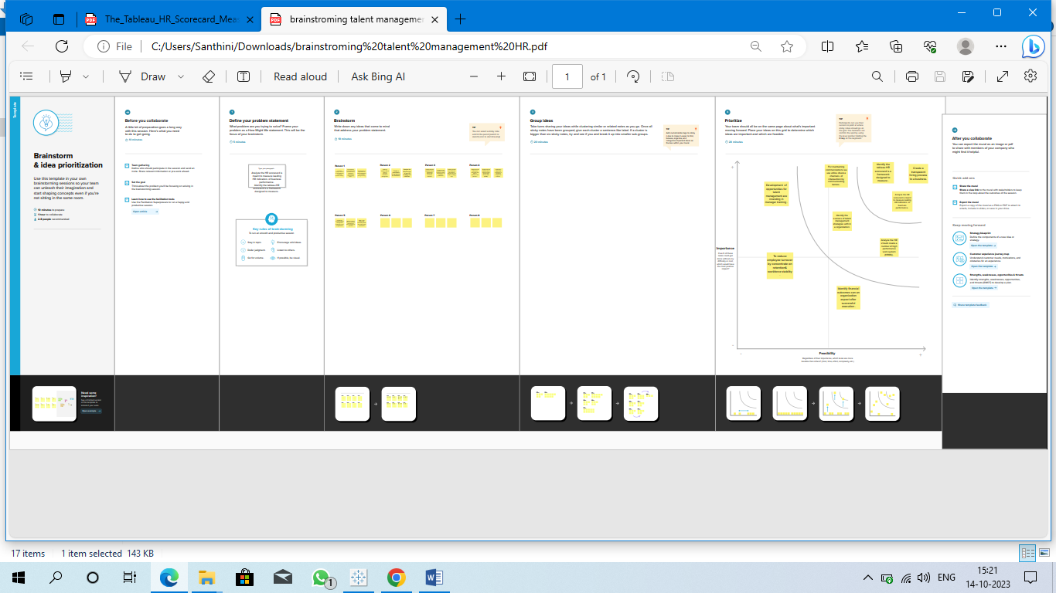

**3. Result**

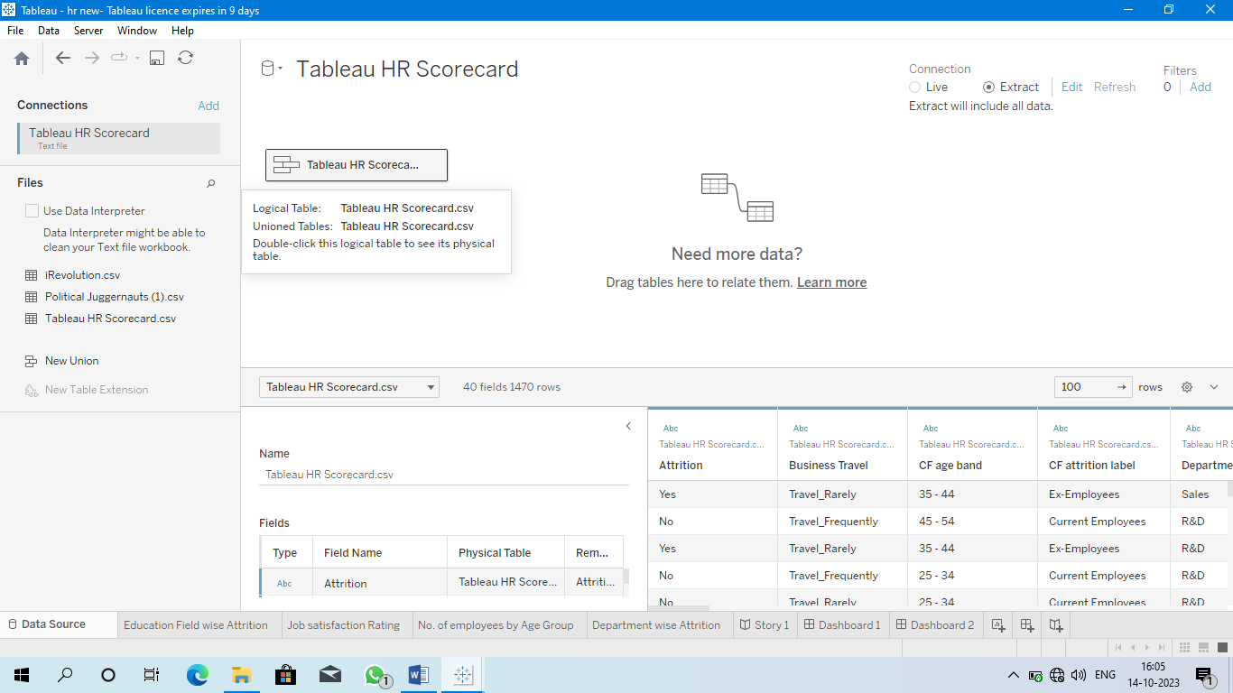

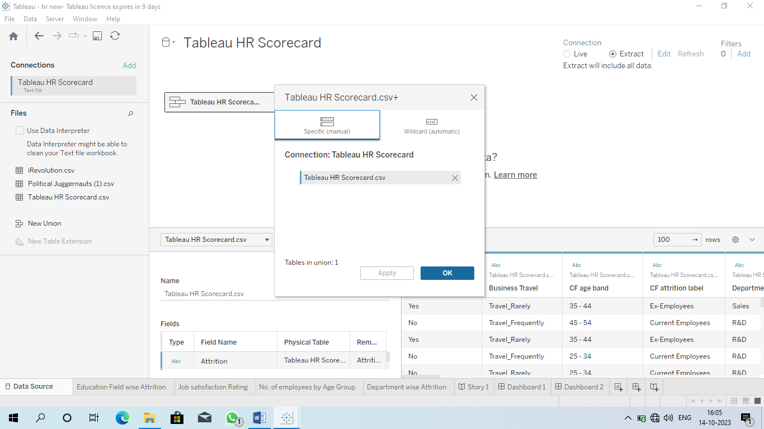

Department wise Attrition

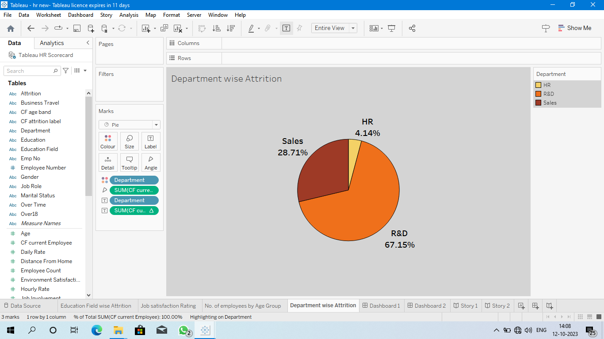

No. of. employees by Age Group

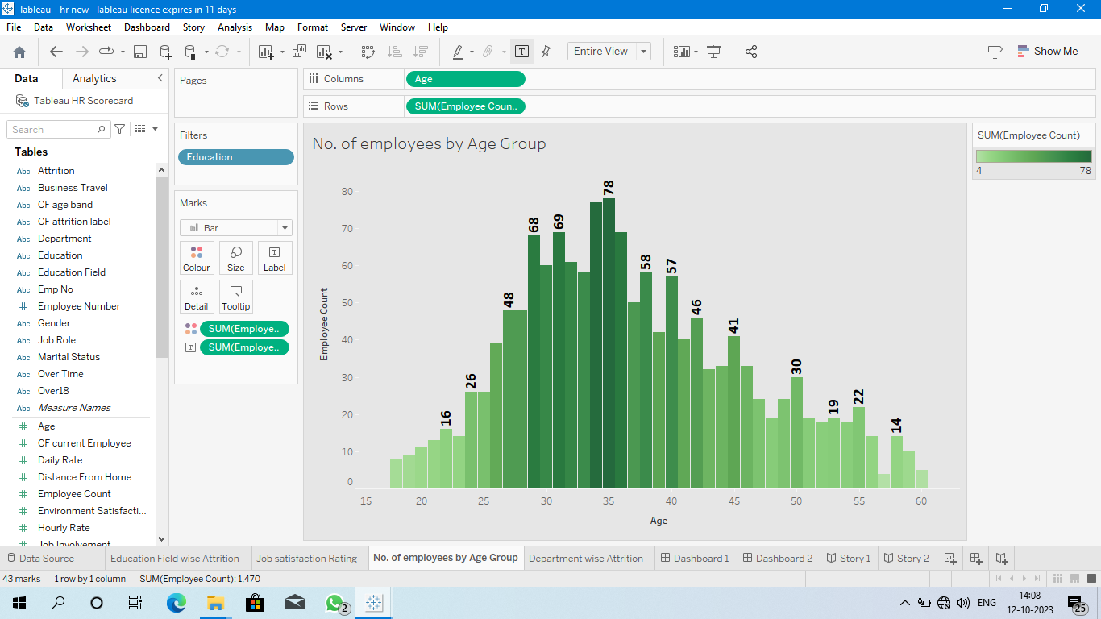

Job Satisfaction Rating

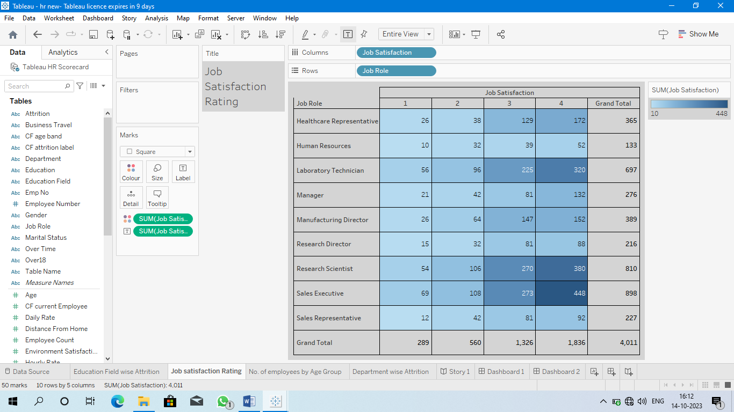

Education field wise Attrition

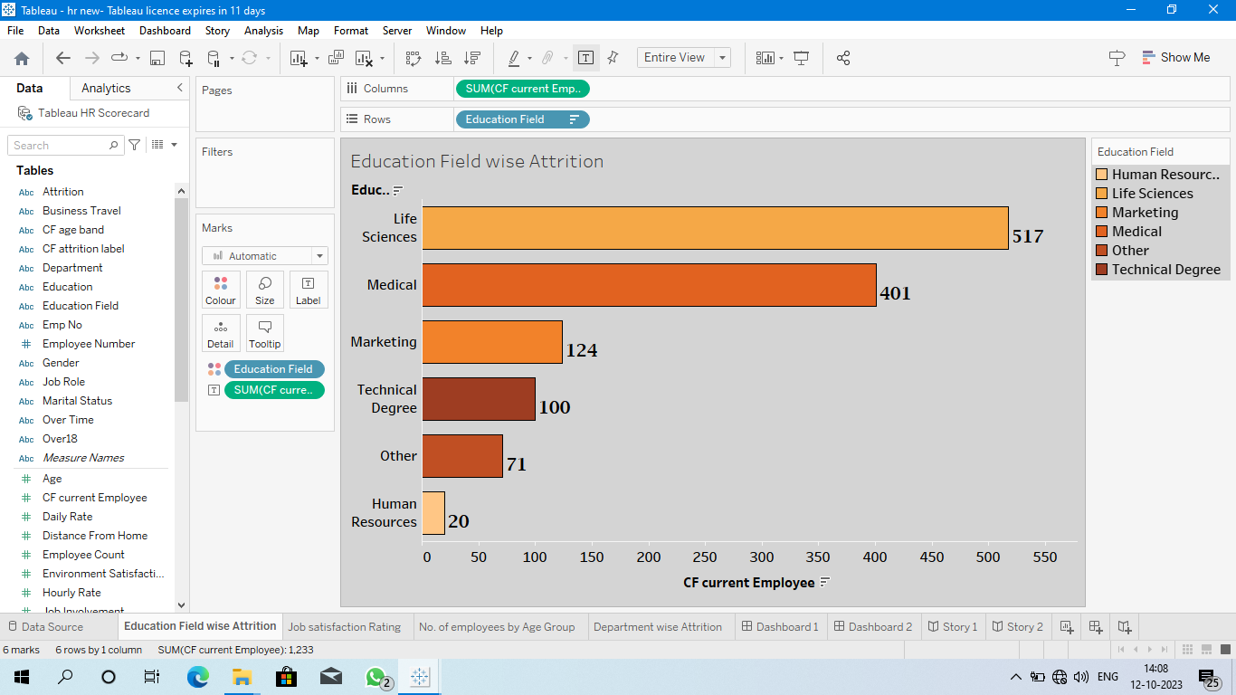

Dashboard 1:

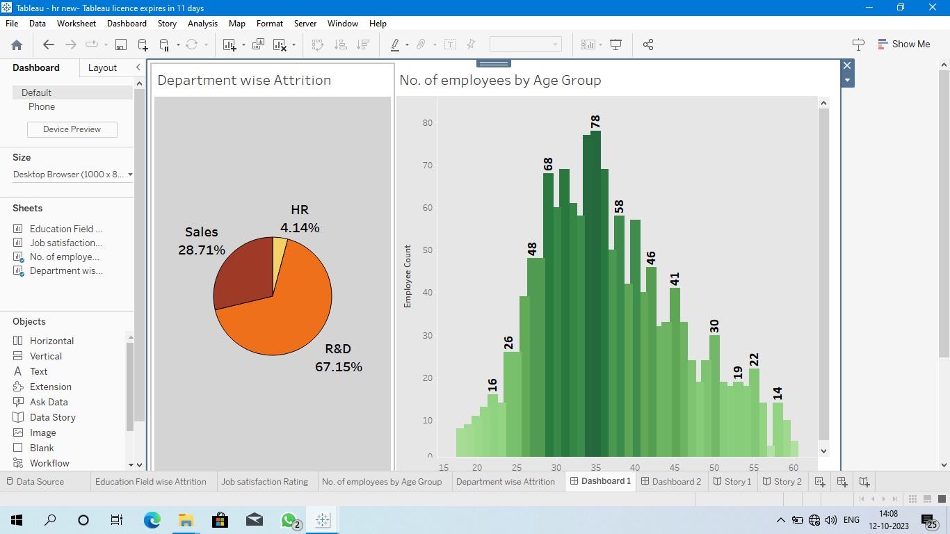

Dashboard 2:

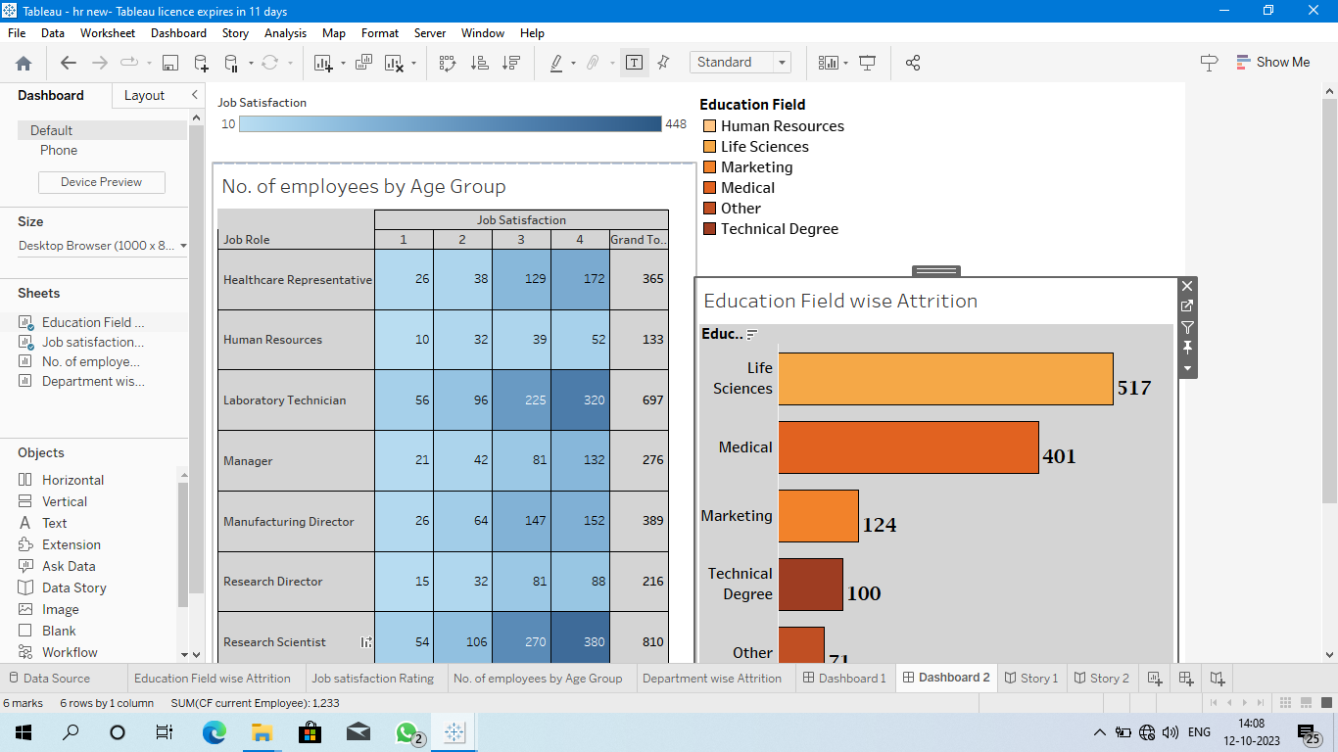

Story 1:

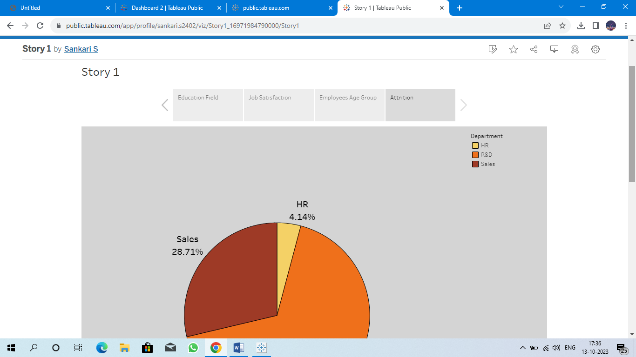

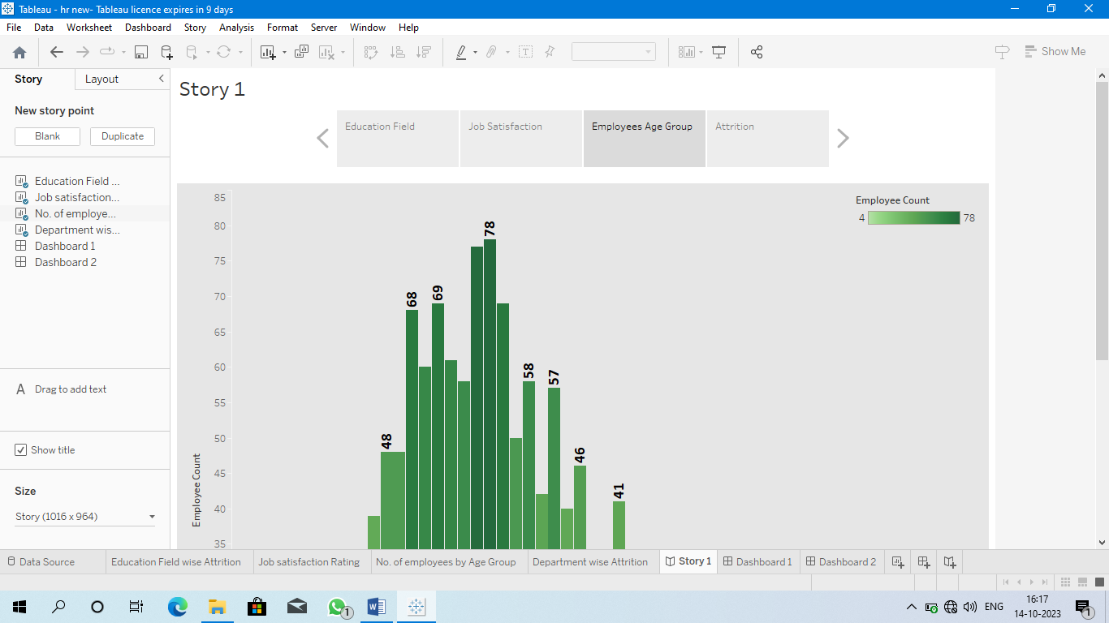

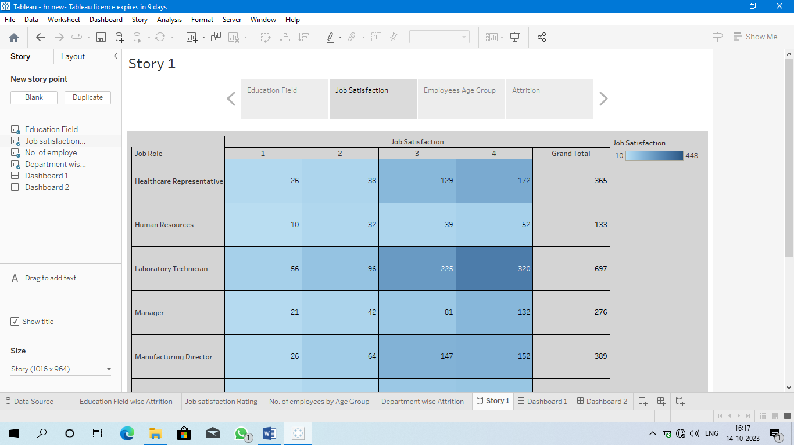

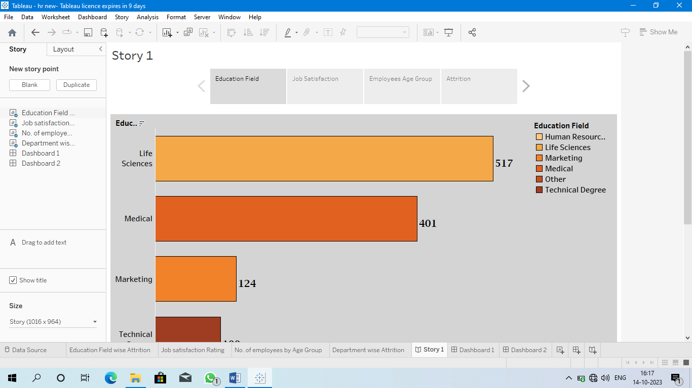

***4. Advantages :***

* **Gives Structure to the strategy**

A Scorecard helps keep the goals at the centre, uses specific parameters to track progress, and follows initiatives for monitoring actions.

* **Improves performance reporting**

This is for designing performances reports and dashboards, ensuring the focus remains on critical strategic issues.

* **Makes it easier to communicate the strategy**

Having a scorecard takes the guesswork out of trying to understand everyone’s responsibilities in the term and gets the entire department synced up under one structure.

***Disadvantages :***

* Even though there are many HR scorecard templates you can use, the framework must be customise to suit your business requirements.
* This can be time- consuming tedious- especially for first-time users.
* HR scorecards can be overly complicated to understand despite their being many case studies and resources to read from.
* HR scorecards usually require managers to report information, which can cause some resistance and even delays.

**5. Conclusion :**

In Conclusion, gone are the days when HR did not contribute value to a company’s strategy. Now, the department plays a direct role in running a business. An HR balanced scorecard provides a framework for achieving that strategic plan. So please consider how your company operates and how the scorecard can be worth the investment.

**6. Future scope:**

In the future, Harnessing the power of data collection, analysis, and interpretation empowers leaders to make informed decisions, refine strategies iteratively, and create a workforce that thrives in an environment of growth and engagement. By putting data at the heart of decision-making and embracing a culture of continuous improvement, organizations can elevate their talent management strategies from mere concepts to thriving engines that drive sustained success, innovation, and competitive advantage in today’s dynamic business landscape